

Foundations of Programming

Assignment No.: 22
PROBLEM STATEMENT: Write a menu driven program in C to perform various string operations using in-built functions.

OBJECTIVE:

- To understand the concept of strings in the C programming language.
- To learn how to use built-in string functions for string manipulation.
- To perform operations such as length calculation, copying, concatenation, comparison, and reversal using menu options.
.

THEORY:
In the C programming language, a string is a sequence of characters terminated by a null character ('\0'). Strings are stored in character arrays and manipulated using functions available in the string.h header file.
Common built-in string functions include strlen() for finding the length of a string, strcpy() for copying one string to another, strcat() for concatenating two strings, and strcmp() for comparing two strings.
A menu driven program allows the user to select different operations from a list of options. Based on the user’s choice, the corresponding string function is executed. This approach makes the program interactive and easy to use.

ALGORITHM:

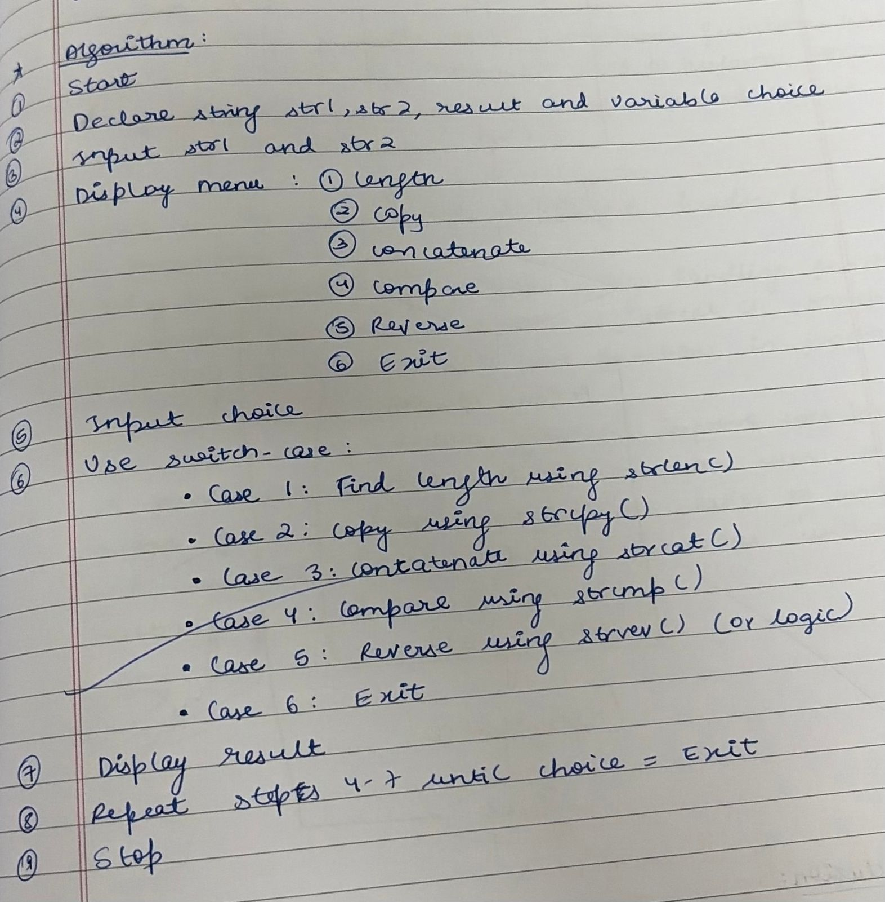

FLOWCHART:

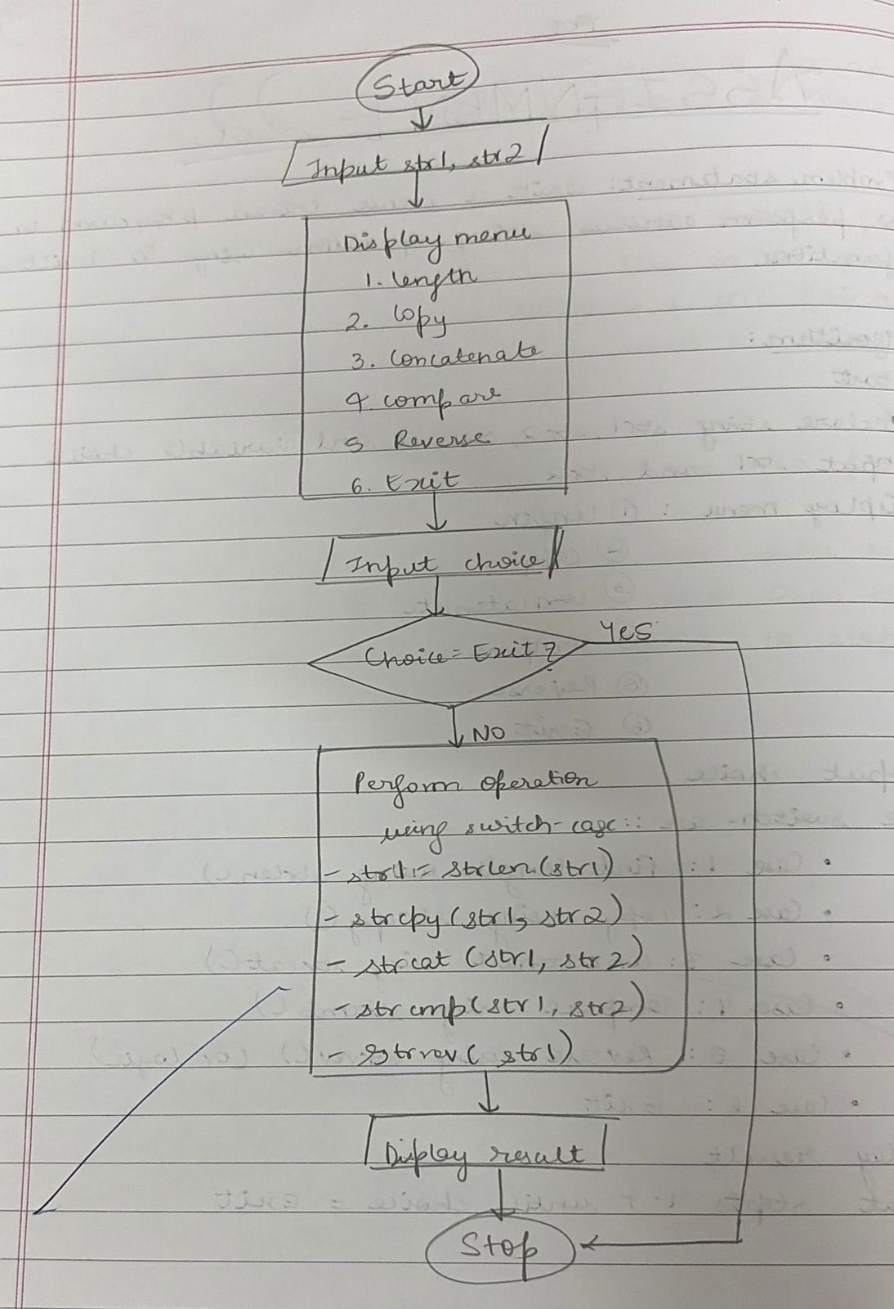
PLATFORM: Linux
CODE:
#include <stdio.h>
#include <string.h>

int main() {
char s1[100], s2[100], t[100];
int ch, i, l;

printf("Enter two strings: ");
scanf("%s %s", s1, s2);

do {
printf("\n1.Len 2.Copy 3.Concat 4.Compare 5.Reverse 6.Exit\n");
scanf("%d", &ch);

switch(ch) {
case 1: printf("Len=%lu\n", strlen(s1)); break;

case 2: strcpy(t, s1);
printf("%s\n", t); break;

case 3: strcpy(t, s1);
strcat(t, s2);
printf("%s\n", t); break;

case 4: if(strcmp(s1,s2)==0) printf("Equal\n");
else printf("Not Equal\n"); break;

case 5: l=strlen(s1);
for(i=0;i<l;i++)
t[i]=s1[l-i-1];
t[l]='\0';
printf("%s\n", t); break;
}

} while(ch!=6);

return 0;
}
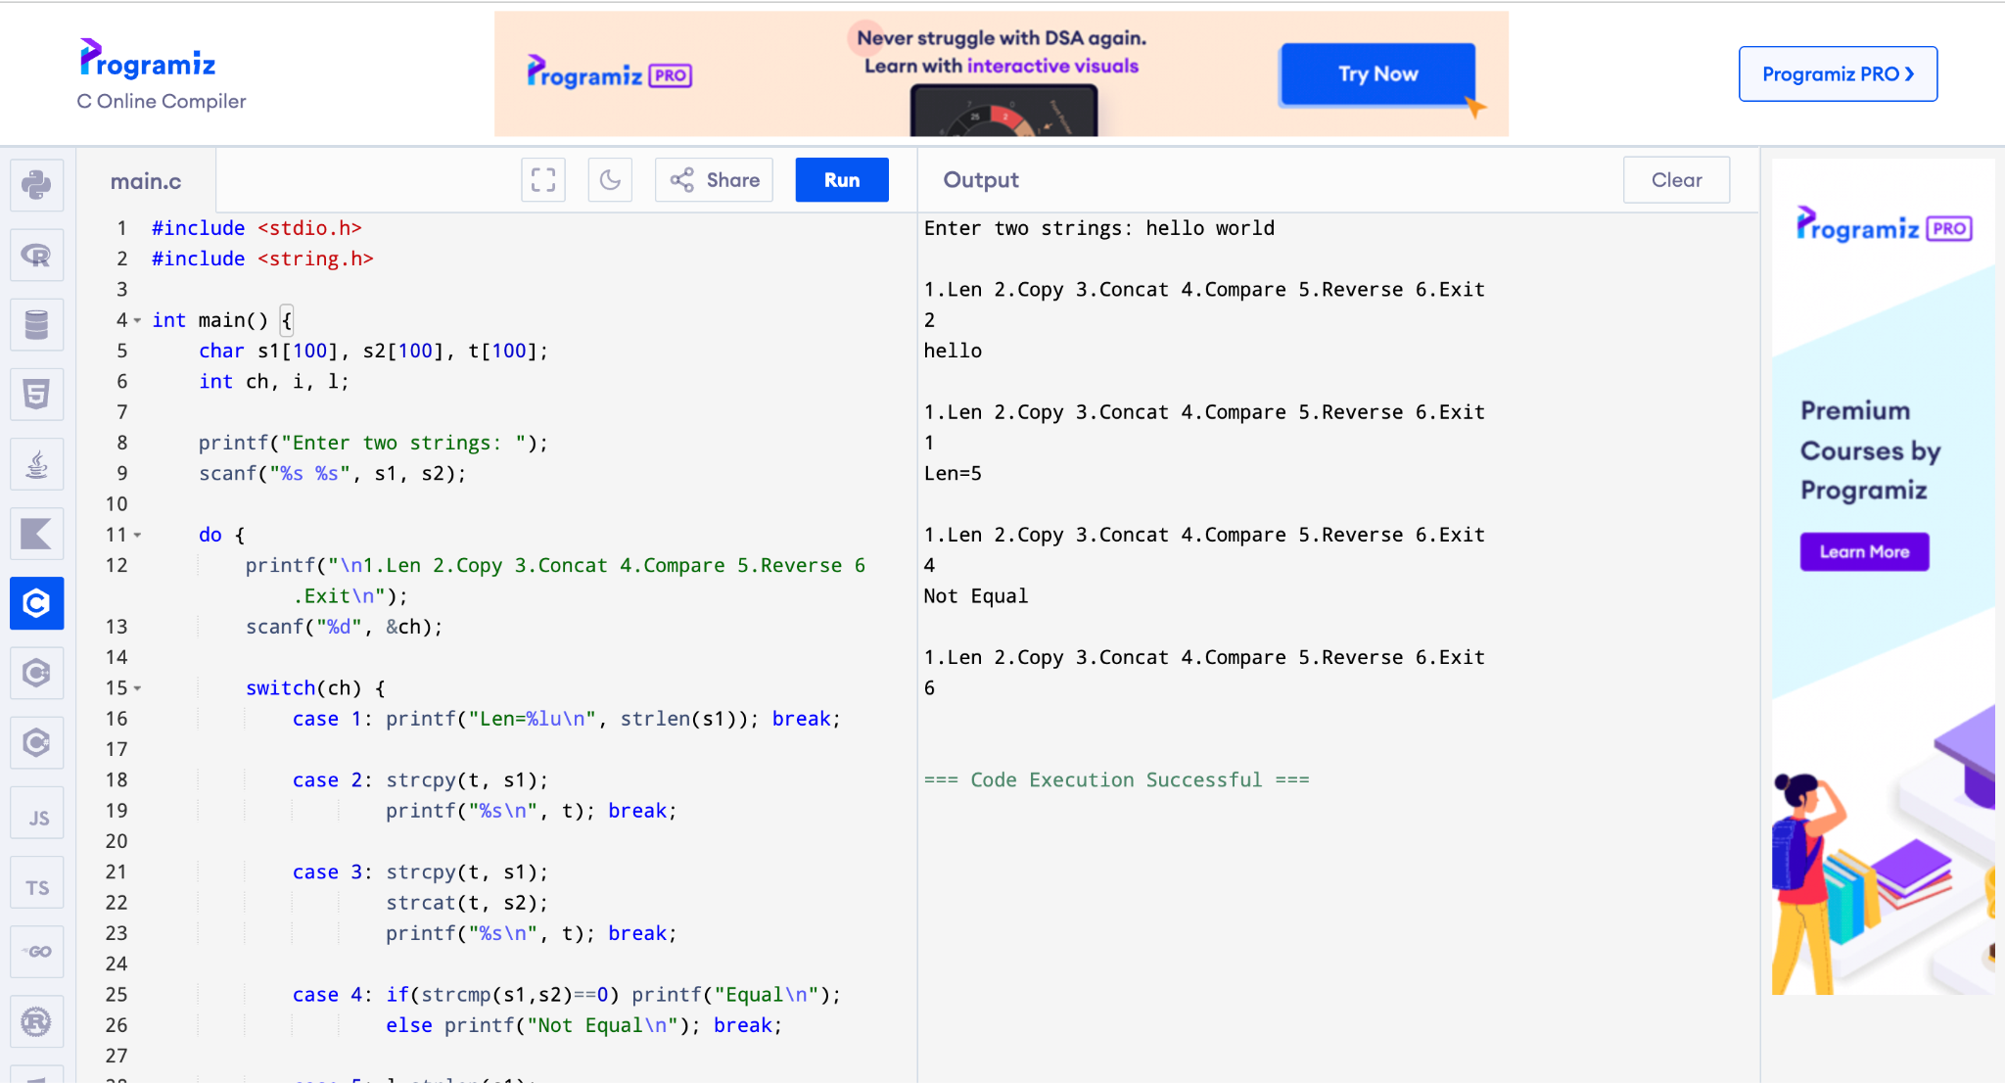

CONCLUSION: Thus, the C program successfully demonstrates different string operations using built-in functions through a menu driven approach, making the program interactive and easy to use.

FAQs:
- What are built-in string functions in C and why are they used?
- What is the purpose of the string.h header file in C programs?
- How does a menu driven program improve user interaction in programming?

